19.68: a) The difference between the pressure, multiplied by the area of the piston, must be the weight of the piston. The pressure in the trapped gas is 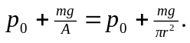

b) When the piston is a distance 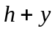 above the cylinder, the pressure in the trapped gas is
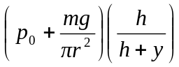
and for values of y small compared to 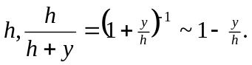The net force, taking the positive direction to be upward, is then

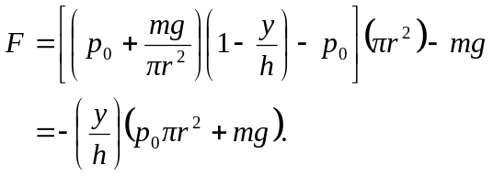
This form shows that for positive h, the net force is down; the trapped gas is at a lower pressure than the equilibrium pressure, and so the net force tends to restore the piston to equilibrium. c) The angular frequency of small oscillations would be

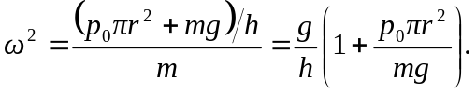

If the displacements are not small, the motion is not simple harmonic. This can be seen be considering what happens if y ~ −h; the gas is compressed to a very small volume, and the force due to the pressure of the gas would become unboundedly large for a finite displacement, which is not characteristic of simple harmonic motion. If y >> h (but not so large that the piston leaves the cylinder), the force due to the pressure of the gas becomes small, and the restoring force due to the atmosphere and the weight would tend toward a constant, and this is not characteristic of simple harmonic motion.

